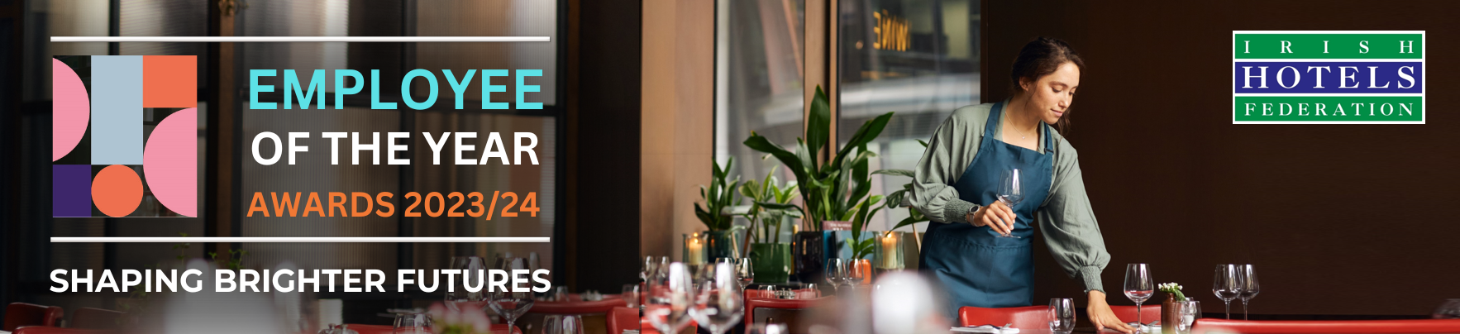
IHF MOURNE BOYNE LAKES BRANCH
EMPLOYEE OF THE YEAR 2023/24
NOMINATION FORM

Entry criteria: the nominee must‌ i) be a full-time or part-time permanent employee, ii) be from craft up to and including supervisory level only, and iii) have a minimum of one year’s experience in the industry.
‌Please note when considering nominees, members should give some thought to the employee’s career progression since commencing employment, their ability to learn new skills, the training they have received, their aptitude and overall contribution to their workplace.
The Nomination deadline is Friday, 3rd November 2023. Nominations are limited to one entry per hotel or guesthouse.
Submit your nomination: once completed, please email a saved copy of this form to awards@ihf.ie.

Your Details:
Name of hotel or guesthouse:
Your name (person making the nomination):
Your job title:
Your email address:
Your mobile / telephone:

Data protection: Please note any personal data collected will be stored securely and used solely for the purposes of administering the nomination and award process in line with GDPR guidelines. If you would like further information regarding this, please contact us at dataprivacy@ihf.ie.
Please see next page to complete details for nominated employee.
Your Nomination:
Name of nominated employee:
Their job title:
Confirmation of consent: (Please enter ‘YES’ to confirm that the nominee consents to this nomination being made):
Career history / progression within your property (brief outline):

In 500 words (or more) please describe below why the above employee should be named ‘IHF Mourne Boyne Lakes Branch Employee of the Year 2023/24’:
(Please support your answer with examples where possible)

