**IHF EMPLOYEE OF THE YEAR 2024/2025**

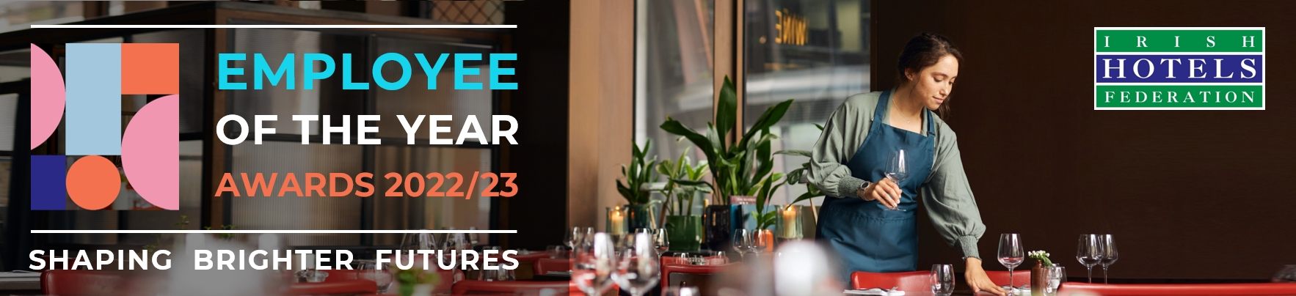

**Mourne, Boyne, Lakes BRANCH**

**Nomination Deadline: Friday, 13th December 2024**

**Entry criteria:** the nominee must‌:

i) be a full-time or part-time permanent employee,

ii) be from craft up to and including supervisory level only, and

iii) have a minimum of one year’s experience in the industry.

**‌Please note** when considering nominees, members should give some thought to the employee’s career progression since commencing employment, their ability to learn new skills, the training they have received, their aptitude and overall contribution to their workplace.

**The Nomination deadline is Friday, 13th December 2024**

**Nominations are limited to one entry per hotel or guesthouse.**

**Submit your nomination:** once completed, please email a saved copy of this form to **awards@ihf.ie**.

**Nominator Details:**

|  |  |
| --- | --- |
| **Name of hotel or guesthouse**: |  |
| **Your name** (person making the nomination): |  |
| **Your job title**: |  |
| **Your email address**: |  |
| **Your mobile / telephone**: |  |

**Data protection:** Please note any personal data collected will be stored securely and used solely for the purposes of administering the nomination and award process in line with GDPR guidelines.If you would like further information regarding this, please contact us at **dataprivacy@ihf.ie**.

**Your Nomination:**

|  |  |
| --- | --- |
| **Name of nominated employee**: |  |
| **Preferred Pronouns:** |  |
| **Their job title**: |  |
| **Confirmation of consent:**  (Please enter ‘**YES**’ to confirm that the nominee consents to this nomination being made)**:** |  |
| **Service Length:** |  |

**Describe how the nominee consistently goes above and beyond in their role** *(front or back of house)***, contributing to exceptional guest experiences or operational excellence.**

**(min. 150 words)**

**How does the nominee demonstrate a commitment to teamwork and collaboration within their department and across other teams in the hotel/guesthouse?**

**(min. 100 words)**

**Provide examples of how the nominee has displayed innovation or problem-solving skills that have positively impacted the hotel/guesthouse’s operations or guest satisfaction.**

**(min. 150 words)**

|  |  |
| --- | --- |
| **Property Prop. / GM Signature** |  |
| **Nominee Signature:** |  |
| **Nominator Signature:** |  |