**IHF Branch: Employee of the Year 2024/2025**

**Interview Preparation Tips**

**Firstly, congratulations on being nominated for the Irish Hotels Federation Branch Employee of the Year 2024/2025.**

**This is a significant achievement and deserves to be celebrated. To help you perform at your best during the interview, we’ve put together some useful tips to guide you through the process.**

**Preparation**

* **Know Your Interviewers:**

Research the individuals interviewing you, their background, and career history.

* **Showcase Your Skills:**

Prepare examples that highlight your skills, personal qualities, and experience. Consider using the STAR method (Situation, Task, Action, Result) to structure your responses.

* **Practice:**

Ask a trusted colleague or friend to help you rehearse answering potential questions.

* **Prepare Your Own Questions:**

Think of two or three thoughtful questions to ask at the end of the interview.

This demonstrates your enthusiasm for the award.

* **Dress Appropriately:**

Select attire that is both professional and comfortable.

* **Plan Your Journey:**

Ensure you know the location of the interview, how to get there, and plan to arrive 5-10 minutes early. Confirm the name of the person you're meeting.

* **Contingency Planning:**

Have contact details ready in case you are delayed. If you have a disability, ensure any necessary accommodations are arranged in advance.

**Arriving *– (Before entering the Interview)***

* **Turn off your phone.**
* **Use calming techniques, such as deep breathing.** *A few nerves are normal.*
* **Greet your interviewer with confidence and a smile.**
* **Ask for water if needed.**

**During the Interview.**

* **Stay Professional:**

Use formal language and a respectful tone.

* **Listen Carefully:**

Take a moment to consider each question before answering.

* **Seek Clarification:**

Don’t hesitate to ask for a question to be repeated or clarified if needed.

* **Use STAR Method:**

Structure your answers using the STAR method to effectively showcase your experiences.

* **Be Positive:**

When discussing challenges, focus on what you learned and how you grew from the experience.

* **Be Honest and Assertive:**

Answer questions truthfully and with confidence.

* **Ask Questions:**

When prompted, ask insightful questions, such as, "When can I expect to hear back about the outcome?"

**Closing the Interview**

**At the end of the interview, thank the panel for their time and express your eagerness to hear from them.**

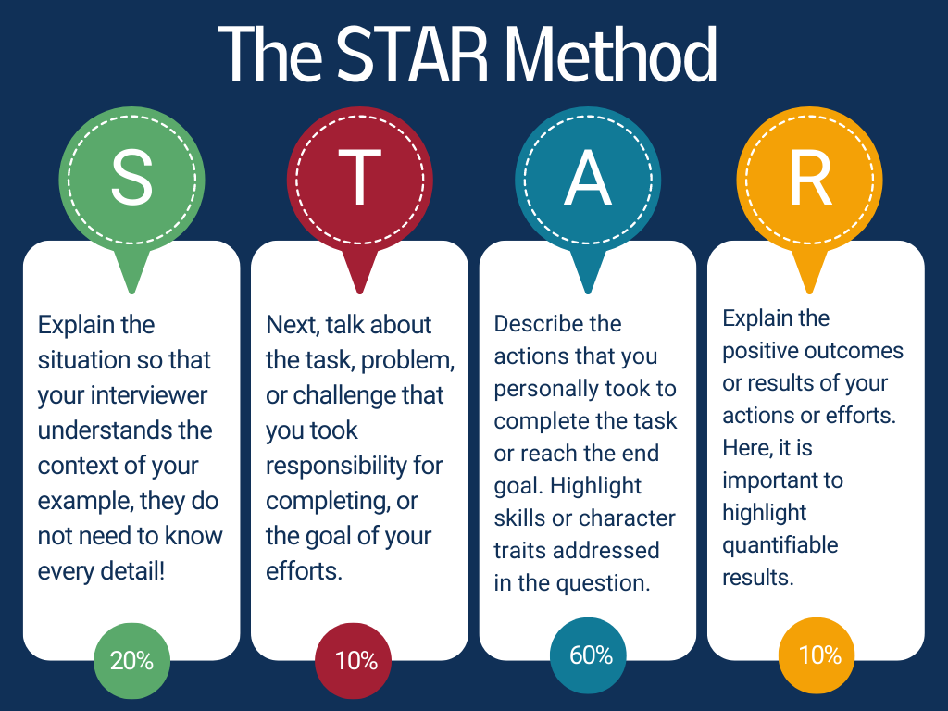

**Example Interview Questions (with Suggested Answers)**

**Tell me about a time when you faced a challenge.**

**How did you solve it?**  
*This question is designed for a STAR method response. Focus on specific challenges and how your actions demonstrated key skills.*

* + **Situation**:

In my current role, our team/department had a short deadline for a major project, which required careful time management.

* + **Task**:

I needed to ensure the team prioritized tasks efficiently to meet the deadline while maintaining quality.

* + **Action**:

I listed the top-priority tasks and focused on completing those before moving on to smaller, less urgent ones.

* + **Result**:

The team successfully completed the project on time, leading to high customer satisfaction and positive feedback from management.

**How do you usually resolve conflict at work?**  
*This question emphasises your problem-solving and communication skills. You should explain how you manage conflict and work toward a resolution with your team.*

* + **Situation**:

A colleague disagreed with a service setup I proposed and became frustrated.

* + **Task**:

I needed to address the disagreement and find a solution that suited everyone.

* + **Action**:

I arranged a short meeting to openly discuss our ideas. Both of us shared our thoughts, and we worked together to merge our suggestions into a final plan.

* + **Result**:

The conflict was resolved, and the team was able to move forward smoothly. This improved team dynamics and productivity on the project.

**Have you ever had to develop new skills in a job?**  
*This question highlights your ability to learn and adapt. You should describe real examples of how you’ve developed new skills and applied them on the job.*

* + **Situation**:

At my property, we introduced new software for front desk and F&B departments, requiring team members to learn updated cashier and booking methods.

* + **Task**:

I needed to develop technical skills to operate the new system efficiently.

* + **Action**:

I participated in on-the-job training with my manager and completed online courses to deepen my understanding of the software.

* + **Result**:

I became proficient in using the new software, which improved our team’s efficiency and streamlined operations.

**GOOD LUCK!**